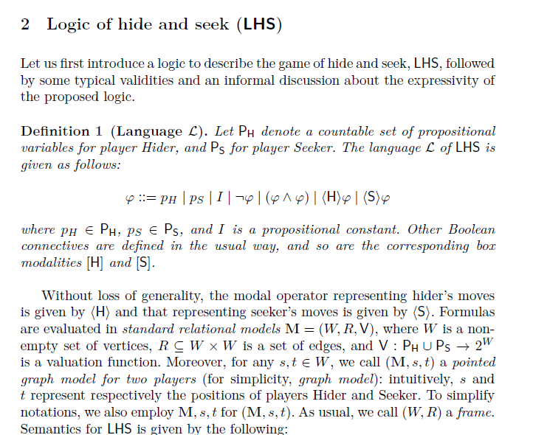

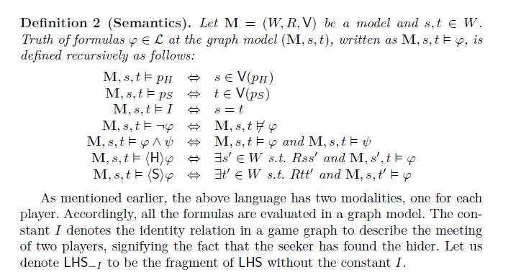



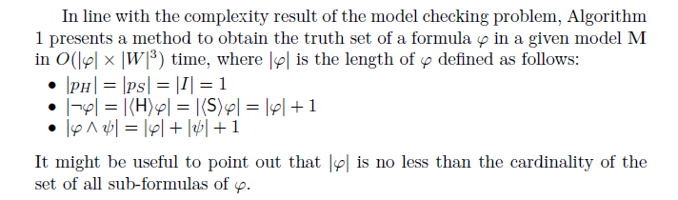

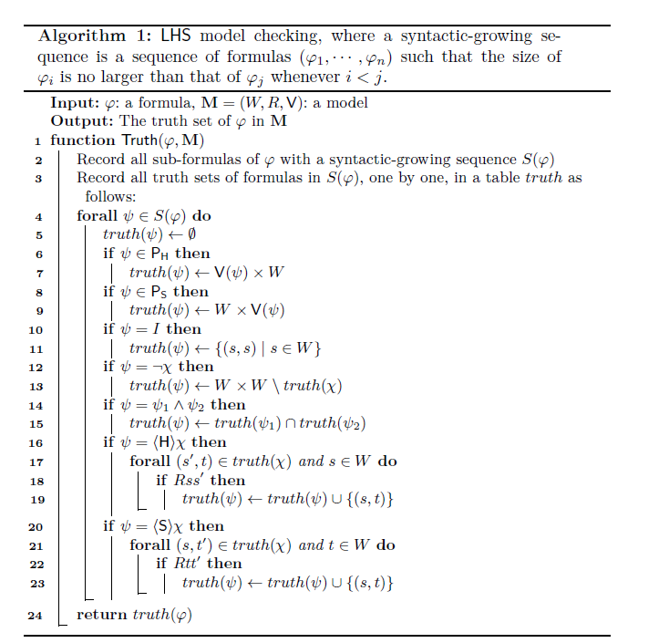

Definition 1 (Language L). Let P_H denote a countable set of propositional

variables for player Hider, and P_S for player Seeker. The language L of LHS is

given as follows:

φ ::= pH | pS | I | ¬φ | (φ ∧ φ) | ⟨H⟩φ | ⟨S⟩φ

where p_H ∈ P_H, p_S ∈ PS, and I is a propositional constant. Other Boolean

connectives are defined in the usual way, and so are the corresponding box

modalities [H] and [S].

Definition 2 (Semantics). Let M = (W,R, V) be a model and s, t ∈ W.

Truth of formulas φ ∈ L at the graph model (M, s, t), written as M, s, t ⊨ φ, is

defined recursively as follows:

M, s, t ⊨ p_H ⇔ s ∈ V(p_H)

M, s, t ⊨ p_S ⇔ t ∈ V(p_S)

M, s, t ⊨ I ⇔ s = t

M, s, t ⊨ ¬φ ⇔ M, s, t \not= φ

M, s, t ⊨ φ ∧ ψ ⇔ M, s, t ⊨ φ and M, s, t ⊨ ψ

M, s, t ⊨ ⟨H⟩φ ⇔ ∃s′ ∈ W s.t. Rss′ and M, s′, t ⊨ φ

M, s, t ⊨ ⟨S⟩φ ⇔ ∃t′ ∈ W s.t. Rtt′ and M, s, t′ ⊨ φ

Algorithm 1: LHS model checking, where a syntactic-growing sequence is a sequence of formulas (φ_1, · · · , φ_n) such that the size of φ_i is no larger than that of φ_j whenever i < j.

Input: φ: a formula, M = (W,R, V): a model

Output: The truth set of φ in M (, i.e. the set of world pairs in which φ is true in M)

1 function Truth(φ,M)

2 Record all sub-formulas of φ with a syntactic-growing sequence S(φ)

3 Record all truth sets of formulas in S(φ), one by one, in a table truth as follows:

4 forall ψ ∈ S(φ) do

5 truth(ψ) ← ∅

6 if ψ ∈ P_H then

7 truth(ψ) ← V(ψ) ×W

8 if ψ ∈ P_S then

9 truth(ψ) ← W × V(ψ)

10 if ψ = I then

11 truth(ψ) ← {(s, s) | s ∈ W}

12 if ψ = ¬χ then

13 truth(ψ) ← W ×W \ truth(χ)

14 if ψ = ψ1 ∧ ψ2 then

15 truth(ψ) ← truth(ψ_1) ∩ truth(ψ_2)

16 if ψ = ⟨H⟩χ then

17 forall (s′, t) ∈ truth(χ) and s ∈ W do

18 if Rss′ then

19 truth(ψ) ← truth(ψ) ∪ {(s, t)}

20 if ψ = ⟨S⟩χ then

21 forall (s, t′) ∈ truth(χ) and t ∈ W do

22 if Rtt′ then

23 truth(ψ) ← truth(ψ) ∪ {(s, t)}

24 return truth(φ)

Algorithm 1 presents a method to obtain the truth set of a formula φ in a given model M in O(|φ| × |W|^3) time, where |φ| is the length of φ defined as follows:

• |pH| = |pS| = |I| = 1

• |¬φ| = |⟨H⟩φ| = |⟨S⟩φ| = |φ| + 1

• |φ ∧ ψ| = |φ| + |ψ| + 1

It might be useful to point out that |φ| is no less than the cardinality of the set of all sub-formulas of φ.

|W|^3应该就来源于W^2上的那个forall以及Rss'提供的量化：首先搜索所有W^2上的(s',t)，然后每个s'搜索一遍R(s,s')

Dazhu Li, Sujata Ghosh, Fenrong Liu, and Yaxin Tu. A simple logic of the hide and seek game